|  |
| --- |
| genweb2 ltd. |
| Samuda HR Payroll User Manual |
| REFERENCE: GW/ERP/USER MANUAL |
|  |
| **Genweb2 Ltd.** |
| **09-May-17** |

|  |
| --- |
| logo.png  **Genweb2 Limited**  TK Bhaban (11th Floor),  13 KaziNazrul Islam Avenue,  Kawran Bazar, Dhaka 1215, Bangladesh  web: [http://www.genweb2.com](http://www.genweb2.com/) |

Contents

1. HR Payroll Management 3

1.1 Create Contribution Registers 3

1.2 Create Salary Rules 4

Salary Rule Categories 4

Salary Rules 5

1.3 Create Salary Structures 6

1.4 Creating Contract Details for Each Employee 7

1.5 Creating Meal Bills for Mess Deduction 8

1.6 Creating Mobile Bill Limits for Mobile Bills Deduction 9

1.7 Creating Mobile Bills for Mobile Bills Deduction 10

1.8 Employee Loan Management 12

1.9 Create Loan Proof 12

1.10 Create Loan Policies 12

1.11 Create Loan Type 12

1.12 Create Loan Request 12

1.13 Loan Request to Approve 12

1.14 Loan to Disburse by Accountant 12

1.15 Create Employee Paysilips 12

1.16 Creating Payslips Batches 13

# 1. HR Payroll Management

Payroll is an integral part of a company’s operations in every organization. It is very important for a company’s financial accounting as well as for its recipient e.g the employees.

**How to install this Module:**   
In order to make use of Payroll and Payroll Accounting features, user needs to install Payroll and Payroll Accounting respectively which can be located in Local Modules under Settings menu.

The following features for efficient payroll management process:-

* **Salary rule:** are used to compute data like allowances, deductions, net, taxes, contribution registers, etc. You can define salary rules by using the expression.
* **Salary structure:** Define a set of rules usually applied to a category of employees. Salary calculation after considering all the allowances, deductions and incentives (if any) etc.,
* **Contribution registers**: A register containing to whom the company or the employee have to pay taxes.
* **Employee and contract:** It includes everything required to compute the salary slip of an employee.
* **Generating Reports.**

## 1.1 Create Contribution Registers

First we need to create contribution registers. Using contribution register you can track the contribution of the employee and company. It is a register that contains to whom the company or the employee have to pay taxes.

Using the menu **Payroll ‣ Contribution Registers** and click **Create.** Registers you can create a Contribution Register.

You need to configure the following:-

**Name**: A name for the Contribution Register.

**Description:** Description related to Contribution Register.

After entering the Contribution Registers information click **Save**.

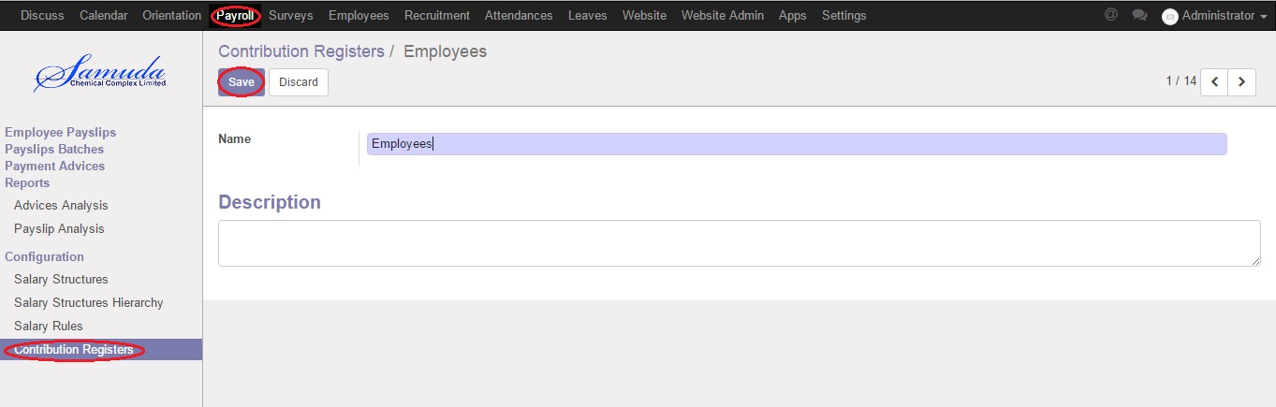

Figure: Create Contribution Registers

After creating a register you can assign it on Salary rule. When Payslip is created, payslip lines generated through salary rules having a contribution register will be linked with that register.

## 1.2 Create Salary Rules

## Salary Rule Categories

Salary Rule Categories are your Basic, Allowance, Deduction, Gross, Net, Company Contribution, etc by using which you can categorize your Salary Rule. You can define Salary Rule Categories by using the menu **Payroll ‣ Salary Rule Categories** and click **Create.**

You can configure the following information:-

**Name:** A name for the Salary Rule Category.

**Code:** A code for the Salary Rule Category. It must be unique.

**Parent:** It is used to create hierarchy for reporting purpose.

After entering the Salary Rule Category information click **Save**.

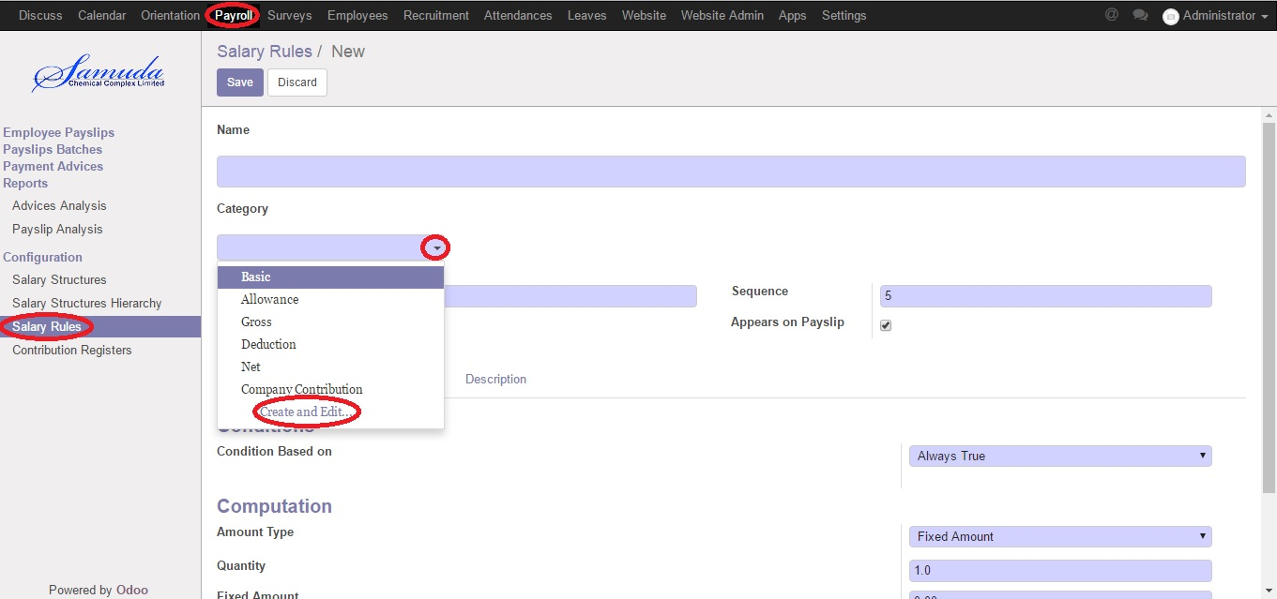

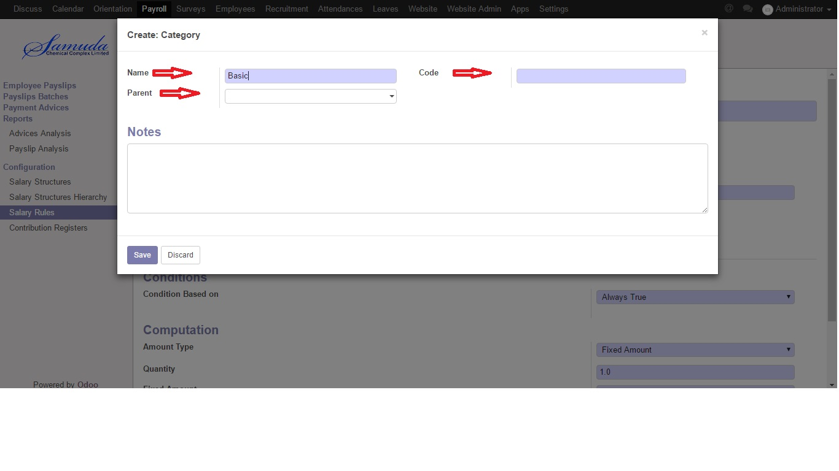

## Salary Rules

Salary Rules are the various types of Allowances, Deductions, etc. You can define Salary Rules by using the menu **Payroll ‣ Salary Rules** and click **Create**.

You can configure the following information:-

**Name:** A name for the Salary Rule.

**Code:** A code for the salary rule. It must be unique.

**Category:** Select a category for a rule.

**Sequence:** Provide the sequence (integer).

After entering the Salary Rule information click **Save.**

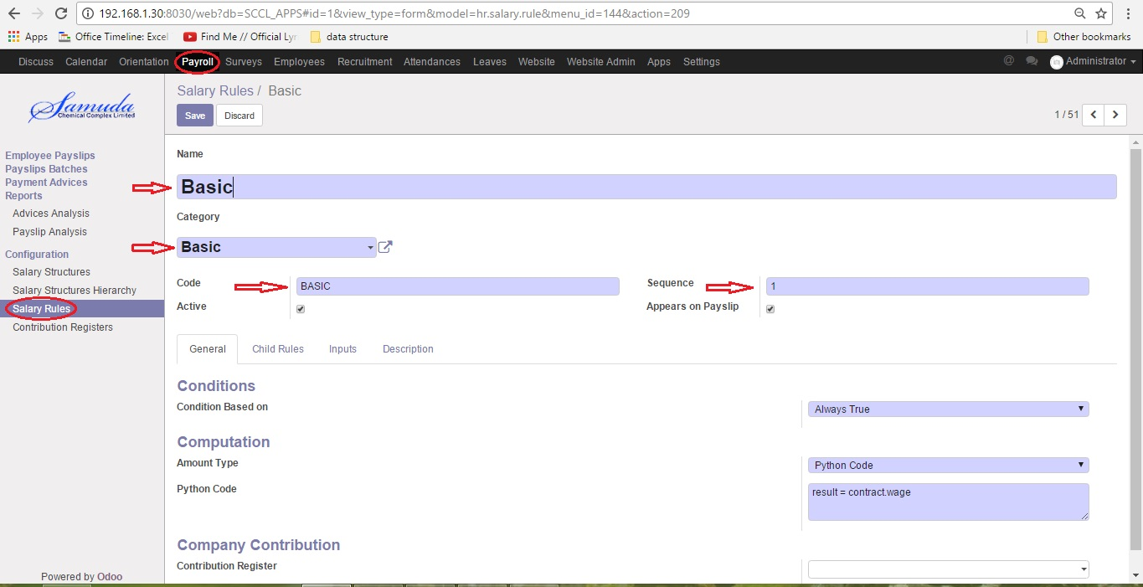

Figure: Create Salary Rules

## 1.3 Create Salary Structures

Salary Structure is a component that decides what should be the Salary of an employee, considering factors such as the individual’s category in an organization, the length of service and the responsibilities an individual is handling etc. It defines a set of rules usually applied to a category of employees. Salary calculation after considering all the allowances, deductions and incentives (if any) etc.

Using the menu **Payroll ‣ Salary Structure** and click **Create**. You can define salary structure.

You can configure the following information:-

**Name:** A name for a salary structure.

**Reference:** A code for a salary structure. It must be unique.

**Parent:** Select a structure whose rules you want to inherit.

**Salary Rules:** Add the salary rules which you want to provide under your structure.

After entering the salary structure information click **Save**.

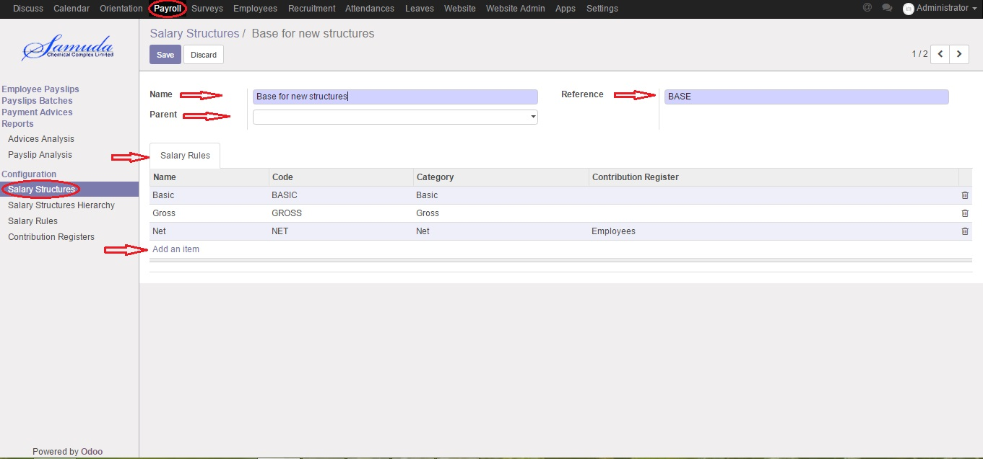

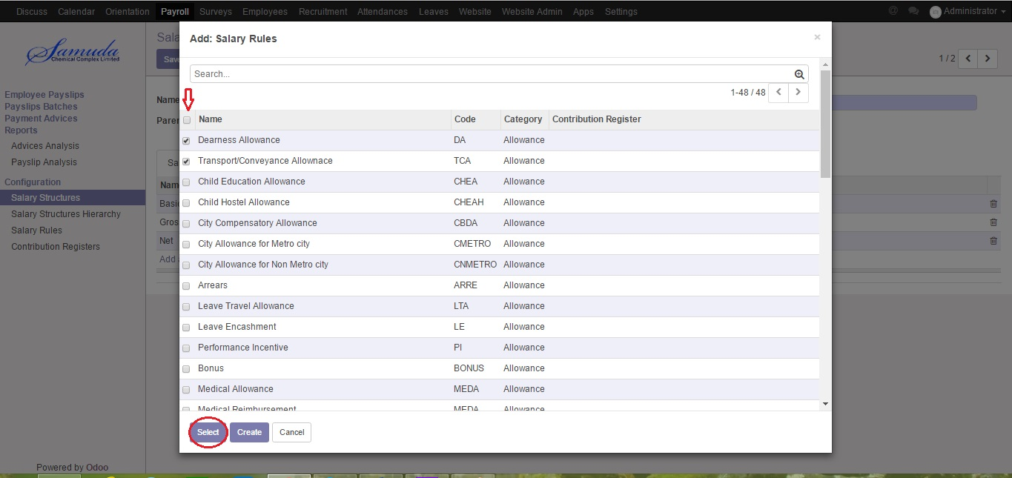

Figure: Create Salary Structures

## 1.4 Creating Contract Details for Each Employee

Contract includes everything required to compute the salary slip of an employee. Contract is linked with employee that contains key information like Basic (Wage), Salary Structure, Scheduled Pay (monthly/weekly), Working Schedule etc. This is important as Payslips are generated on the basis of salary structure which consists of Allowances, Deductions etc.

Using the menu**Employees ‣ Contracts** and click **Create**. You can define contract.

Installation of payroll module adds the following fields on contract:-

**Salary Structure:** Salary structure for payslip.

**Wage:** Basic Salary of Employee

**Scheduled Pay:** When a salary/wages are scheduled to be paid. e.g. monthly, weekly, quarterly, etc

After entering the contract information click **Save**.

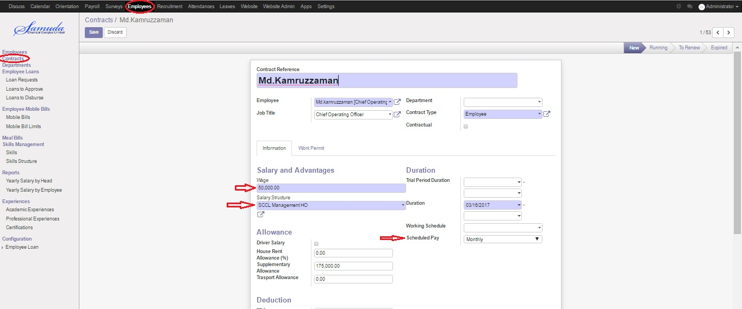

Figure: Creating Contract Details

## 1.5 Creating Meal Bills for Mess Deduction

Meal Bills what can keep record for all employee’s monthly meal bills. You can define Meal Bills by using the menu **Employees ‣ Meal Bills** and click **Create**. You can configure the following information:-

**Description:** A name for the Meal Bills.

**Employee Name:** Select an employee name.

**Amount:** Input meal bill amount for selected employee.

After entering the Meal Bills information click **Save.**

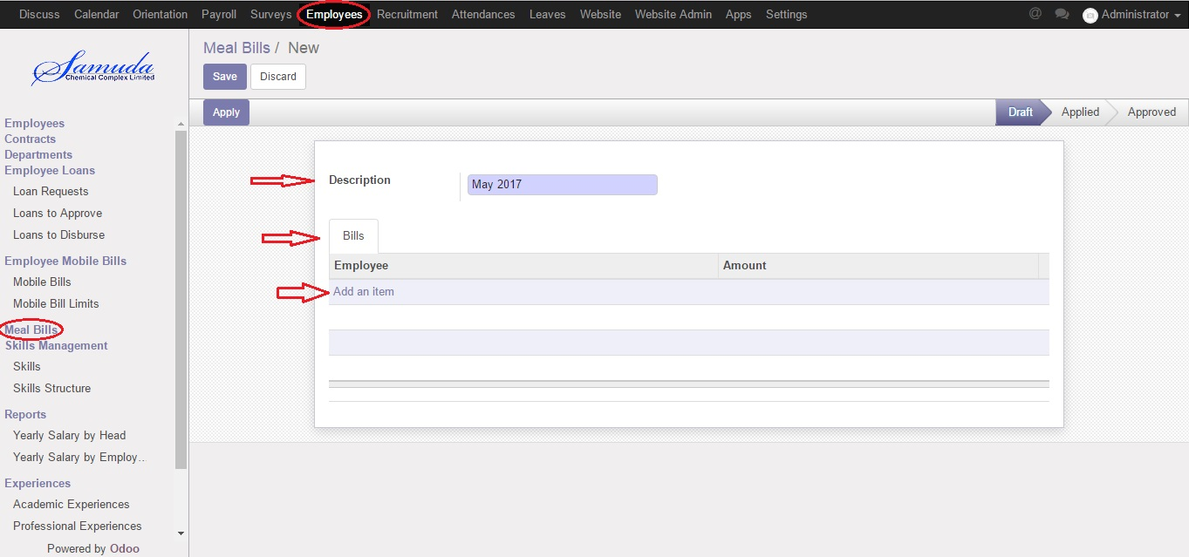

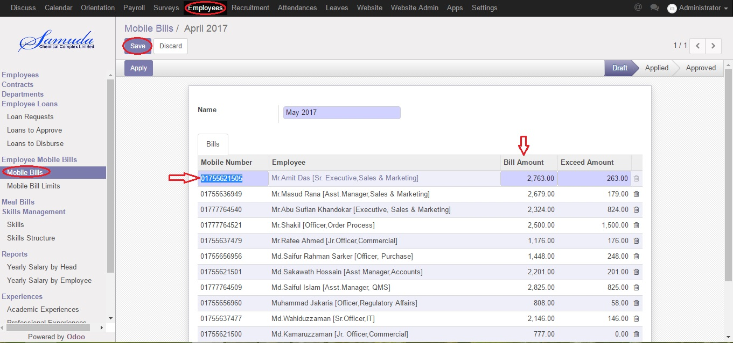

Figure: Creating Meal Bills

## 1.6 Creating Mobile Bill Limits for Mobile Bills Deduction

Mobile Bills Limits what can keep record all employee’s monthly mobile bill limits. You can define Mobile Bill Limits by using the menu **Employees ‣ Employee Mobile Bills ‣ Mobile Bill Limits** and click **Create**. You can configure the following information:-

**Name:** A name for the Mobile Bill Limits.

**Effective Date:** An effective date for Mobile Bill Limits.

**Employee Name:** Select an employee name.

**Mobile Bill Limit:** Input mobile bill limit amount for selected employee.

After entering the Mobile Bill Limits information click **Save.**

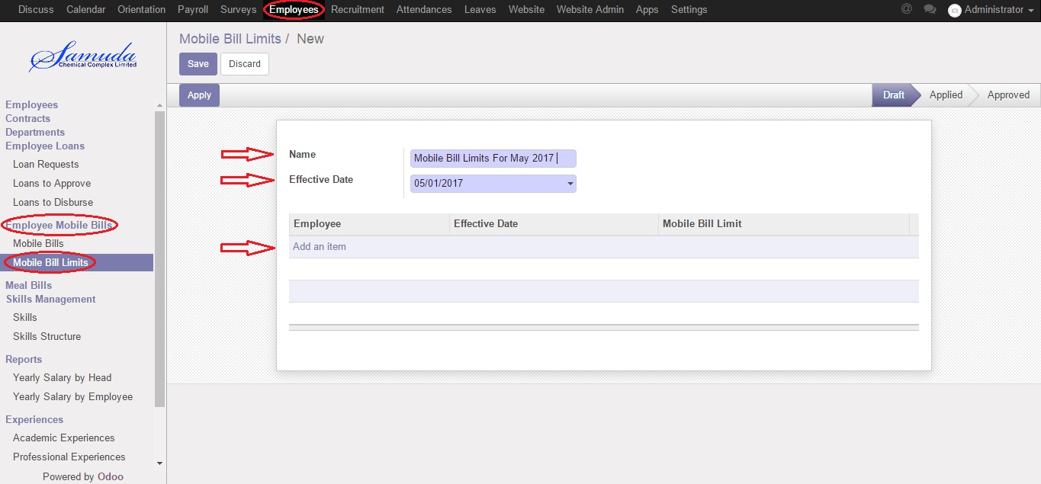

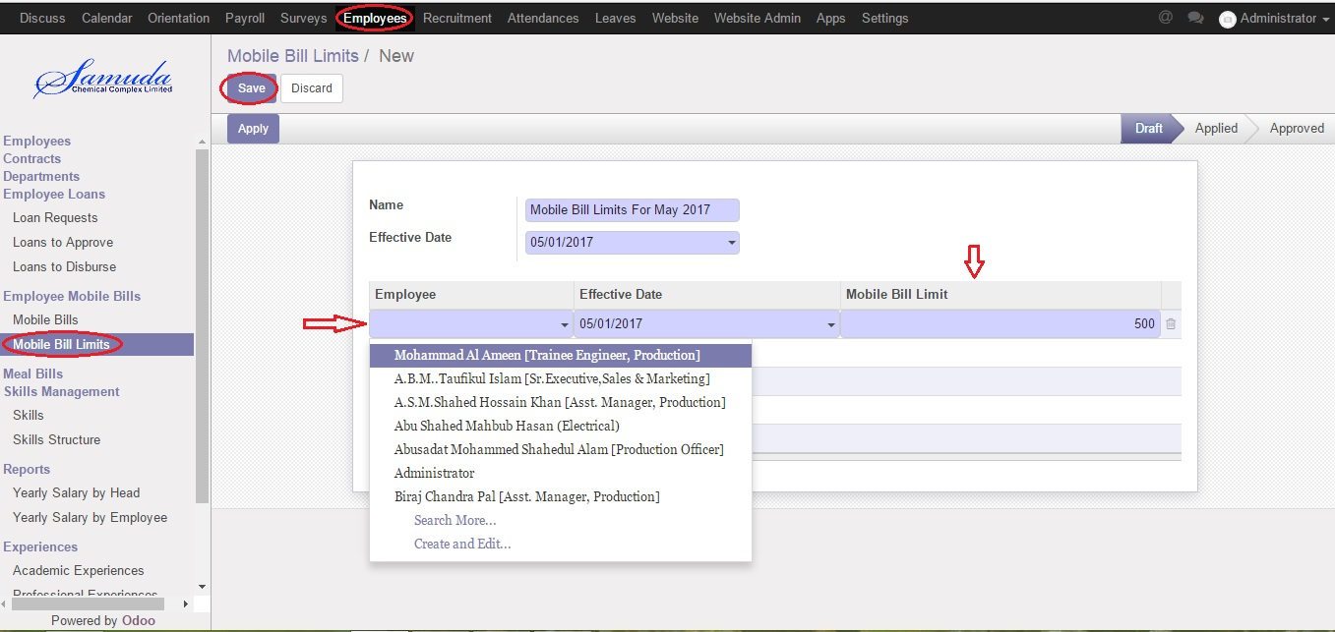

Figure: Creating Mobile Bill Limits

## 1.7 Creating Mobile Bills for Mobile Bills Deduction

Mobile Bills Module what help you to calculate monthly mobile bill amount of employees. You can define Mobile Bills by using the menu **Employees ‣ Employee Mobile Bills ‣ Mobile Bills** and click **Create**.

You can configure the following information:-

**Name:** A name for Mobile Bills.

**Mobile Number:** A Mobile Number for an employee what must be match that employee’s contract information. It must be unique.

**Bill Amount:** Provide mobile bill amount of that month with add limit for that selected employee e.g employee: Amit Das, mobile bill limit: 2500, mobile bill of May: 263. So Bill amount will be 2500+263=2763 what auto calculate Exceed Amount.

After entering the Mobile Bills information click **Save.**

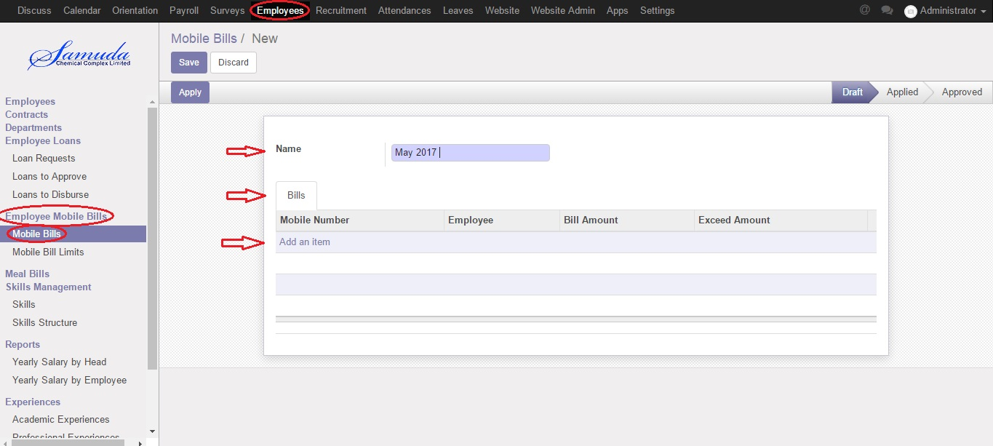



Figure: Creating Mobile Bills

## 1.8 Employee Loan Management

Loan Module provides employee loans, this module enables you to define and manage employee loan policies and their entitlement based on different parameters. Employees can request loans, which are then reviewed and approved, and converted to loan agreement which include terms of payment and the life of the loan. Loan payments are processed automatically through the payroll at the end of each pay period. It can manage advance through the same process.

**How to install this Module:**   
In order to make use of Loan Management features, user needs to install Loan Module respectively which can be located in Local Modules under Settings menu.

The following features for efficient payroll management process:-

* Loan Request and Approval
* Loan Disbursement by Accountant
* Loan Report
* Loan Proofs Setup
* Loan Types Configuration
* Loan Policy Configuration
* Repayment of Loan by Payroll - Integrated with Payroll System
* Repayment of Loan by Cash/Bank
* Disbursement using Cash/Bank or Payroll
* Loan Installments and Booking Interest and Booking entry if repayment method = cash/bank

## 1.9 Create Loan Proof

This loan proof menu allow HR manager to create and configure all loan proofs that will be required to approve loan and process it. These loan proofs will be selected on loan types and then it will be visible on loan request form.

Using the menu **Employee ‣ Configuration ‣ Employee Loan ‣ Loan Proofs** and click **Create.**

You need to configure the following:-

**Name**: A name for the Loan Proof.

**Mandatory:** If true, just a click and make right mark.

After entering the Loan Proof information click **Save**.

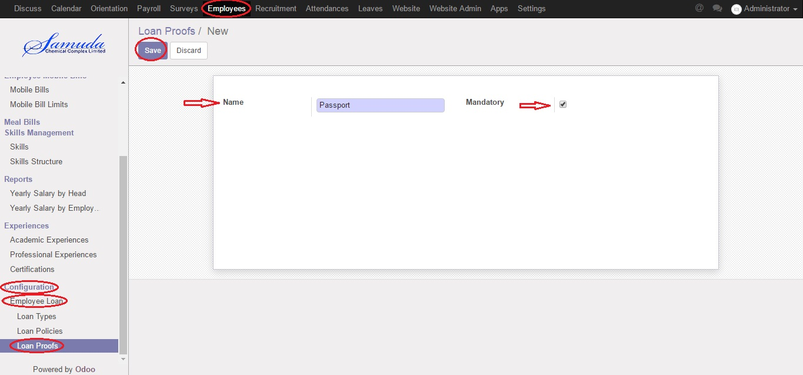

Figure: Create Loan Proofs

## 1.10 Create Loan Policies

HR manager can configure policies or rules for loan request and based on that rules it will check before approving loan that if employee full fill that policy or not.

Using the menu **Employee ‣ Configuration ‣ Employee Loan ‣ Loan Policies** and click **Create.**

You need to configure the following:-

**Name**: A name for the Loan Policy.

**Code:** A code for the Loan Policy. It must be unique.

**Policy type:** Select a Policy Type.

**Basis:** Select a Basis

**Value:** Input an amount of Value.

**Employee Categories:** Click **add an item** and select Employee Tag.

**Employees:** Click **add an item** and select Employees.

After entering the Loan Policies information click **Save**.

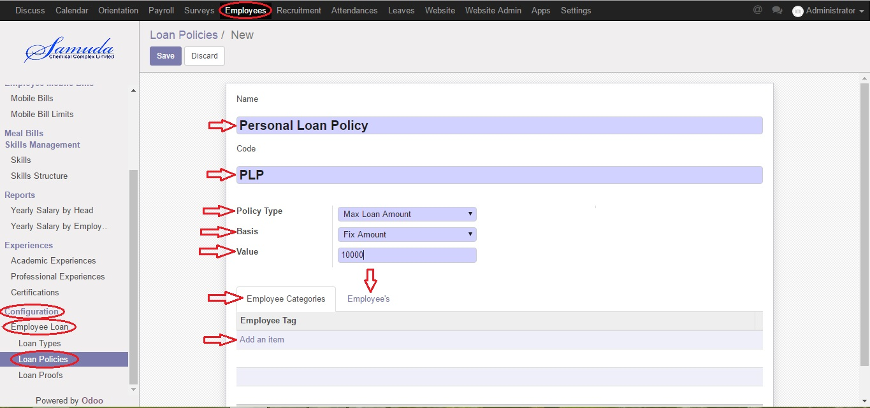

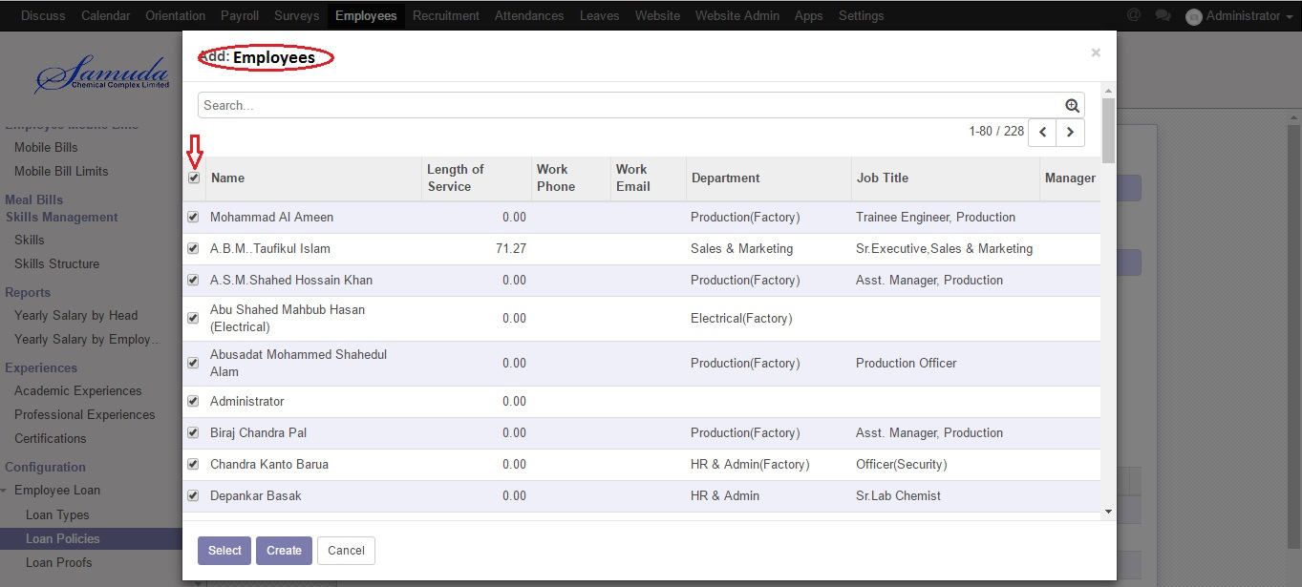

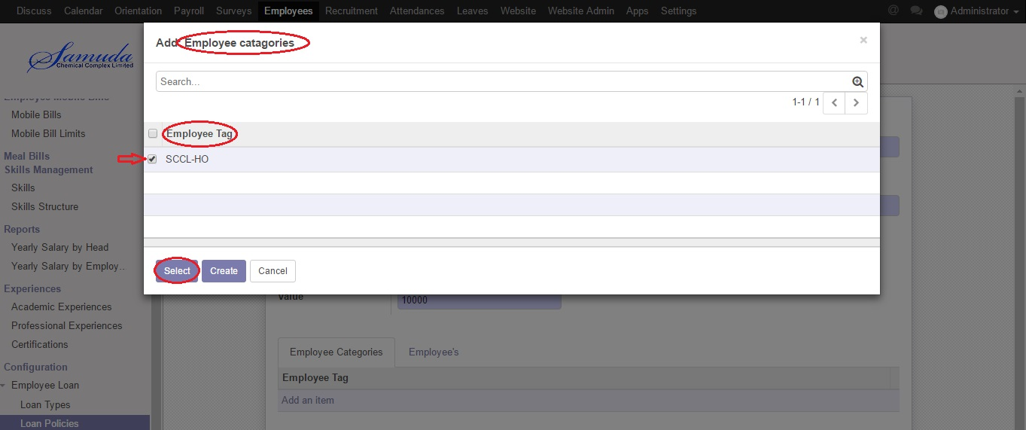

Figure: Create Loan Policies

## 1.11 Create Loan Type

This loan types allow HR manager to create different types of loan for employees. Also it will allow to configure that loan type repayment method will be from payroll or direct cash/bank cheque from Employee at time of installment payment. This also allow to configure disburse method will be by payroll or cash/bank. (Disbursement can be done when loan request will be approved).

Here HR manager can list out Employee categories and employees which can request for this type of loan from company..... For example if Employee A is not eligible and not come under category selected in loan types then system will not allow him/her to submit loan request. Loan proof also configured here so that we can state that these proofs will be needed to process loan request for employee.

Using the menu **Employee ‣ Configuration ‣ Employee Loan ‣ Loan Type** and click **Create.**

You need to configure the following:-

**Name**: A name for the Loan Type.

**Code:** A code for the Loan Policy. It must be unique.

**Interest Account:** Select an Interest Account.

**Repayment Method:** Select an Interest Account.

**Disburse Method:** Select an Interest Account.

**Employee Categories:** Click add an item and select Employee Tag.

**Loan Proofs:** Click **add an item** and select Loan Proofs.

**Loan Policies:** Click **add an item** and select Loan Policies.

After entering the Loan Type information click **Save**.

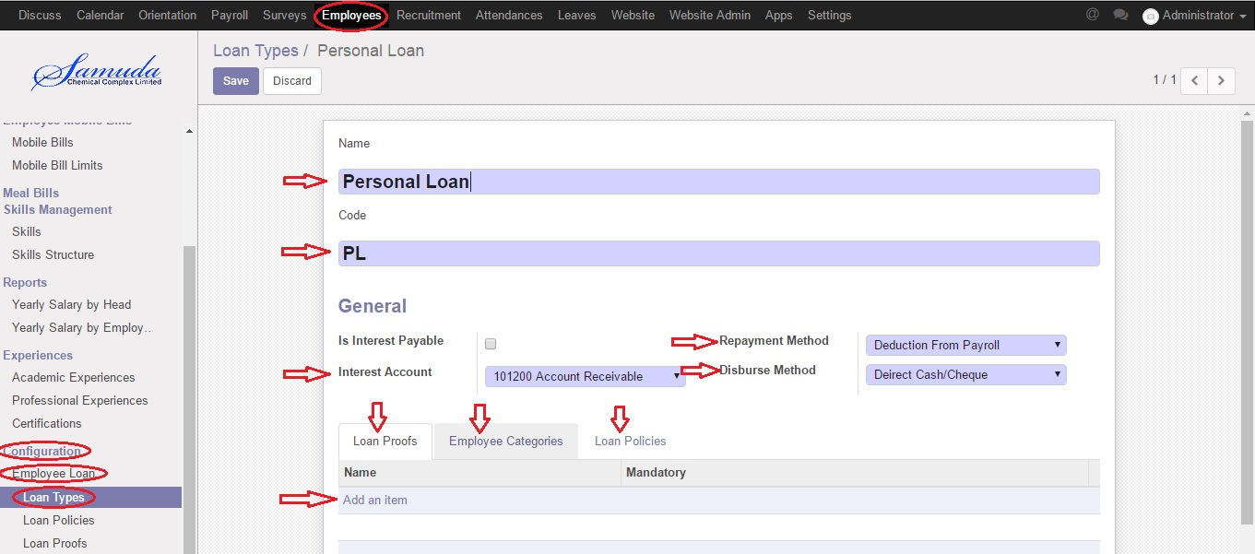





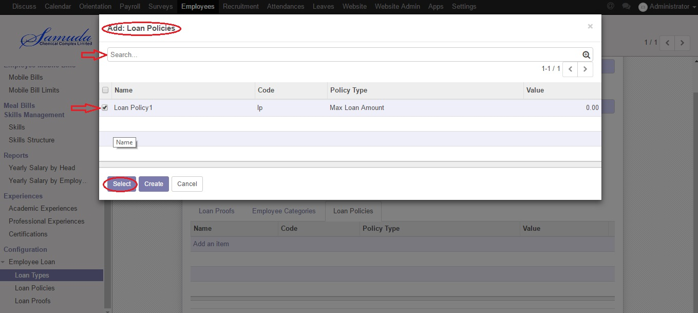Figure: Create Loan Types

## 1.12 Create Loan Request

Employee can apply for loan through Loan Request and the authorized user or admin will get alert for new loan request.

Using the menu **Employee ‣ Employee Loans ‣ Loan Requests** and click **Create.**

You need to configure the following:-

**Employee Name**: A name for the Loan Type.

**Loan type:** Select a Loan Type.

**Principal Amount:** Input a Principal Amount.

**Repayment Date:** Select a Repayment Date.

**Duration:** Input number of installment months.

**Loan Proofs:** Click **add an item** and select Loan Proofs.

**Loan Policies:** Click **add an item** and select Loan Policies.

After entering the Loan Request information click **Save** and **Apply**.

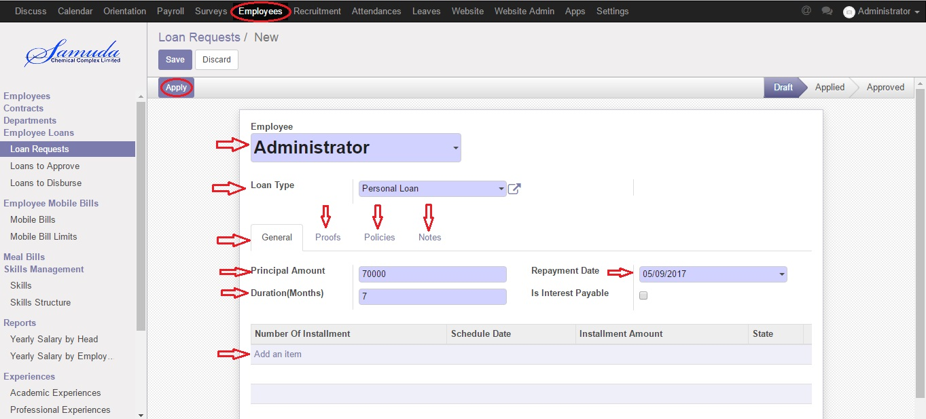

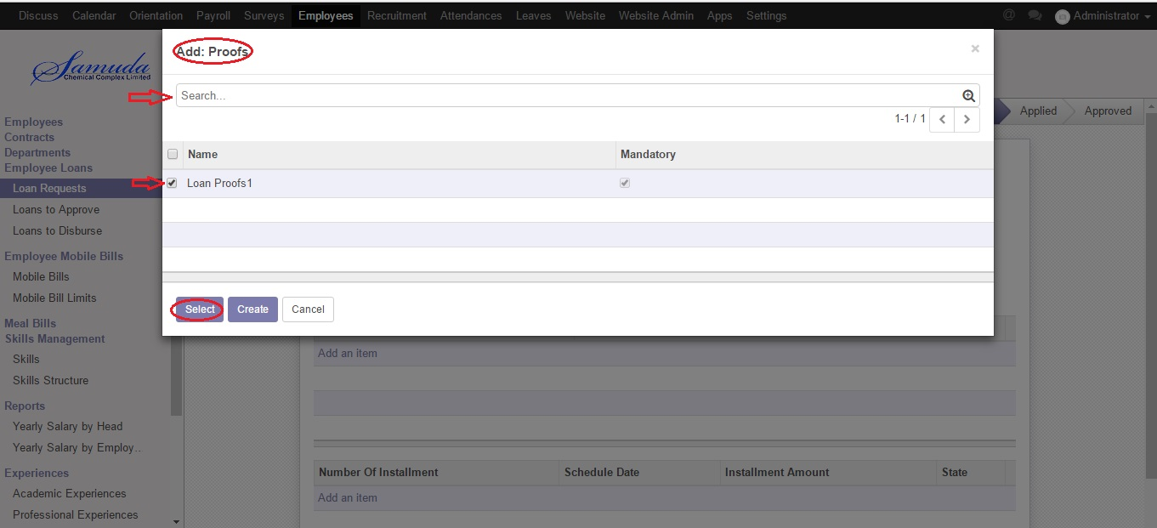



Figure: Create Loan Requests

## 1.13 Loan Request to Approve

Employee can’t approve Loan Request but the authorized user or admin can’t approve Loan Request. Using the menu **Employee ‣ Employee Loans ‣ Loan to Approve** and clickeachemployee loan request and click **Compute** button**.**

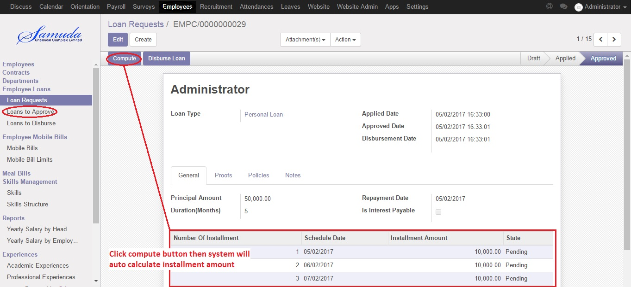

Figure: Create Loan Request to Approve

## 1.14 Loan to Disburse by Accountant

The authorized user or admin or accountant can approve Disburse Loan.

Using the menu **Employee ‣ Employee Loans ‣ Loan to Disburse** and click **Disburse Loan** button**.**

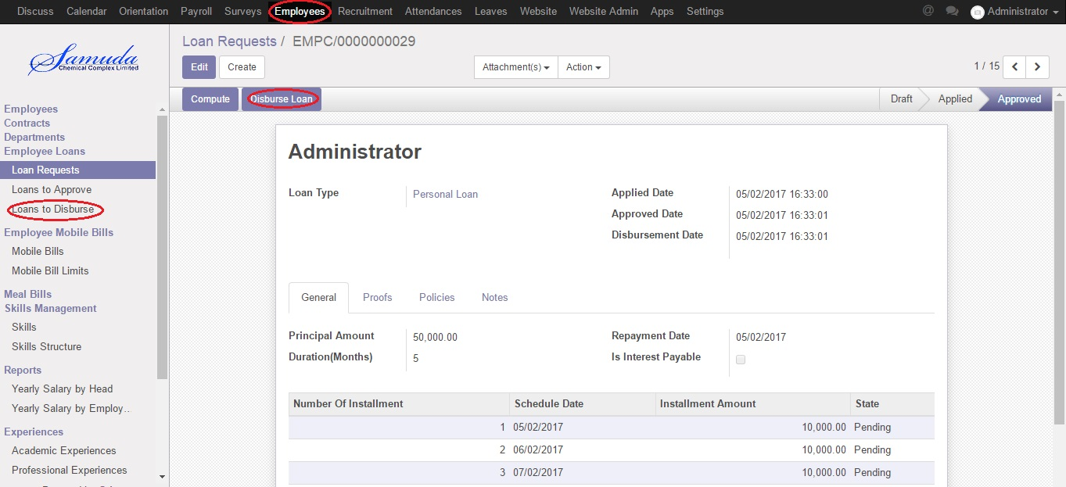Figure: Create Loan to Disburse

## 1.15 Create Employee Paysilips

Using the menu **Payroll ‣ Employee Payslips** and click **Create** you can generate payslips.

You can configure the following information:-

**Employee :** Select an employee.

**Reference :** Slip number.

**Contract :** Select a contract to be considered for payslip.

**Structure :** Salary Structure for generating payslip lines.

**Description :** Description of payslip.

**Credit Note** : If True, indicates this payslip has refund of another.

**Date From :** The beginning date of pay period.

**Date To :** The last date of pay period.

After entering the Employee Paysilips click **Save**.

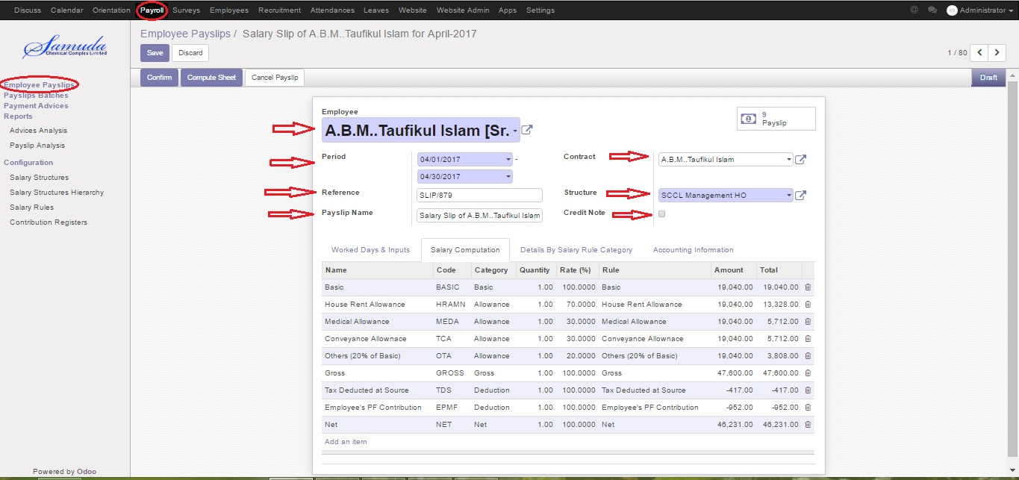

Figure: Generate Employee Paysilips

## 1.16 Creating Payslips Batches

Using the menu **Payroll ‣ Payslips Batches** and click **Create** you can create payslips for various employees at a time.

You need to configure the following:-

**Name:** A name for Payslips Run.

**Date From:** The beginning date of pay period which will be the Date From for payslips to be created.

**Date To:** The last date of pay period which will be the Date To for payslips to be created.

**Credit Note:** If True, indicates that all payslips generated from here are refund payslips.

Click on the Generate Payslips wizard will let you choose the employees for which you want to generate payslips.

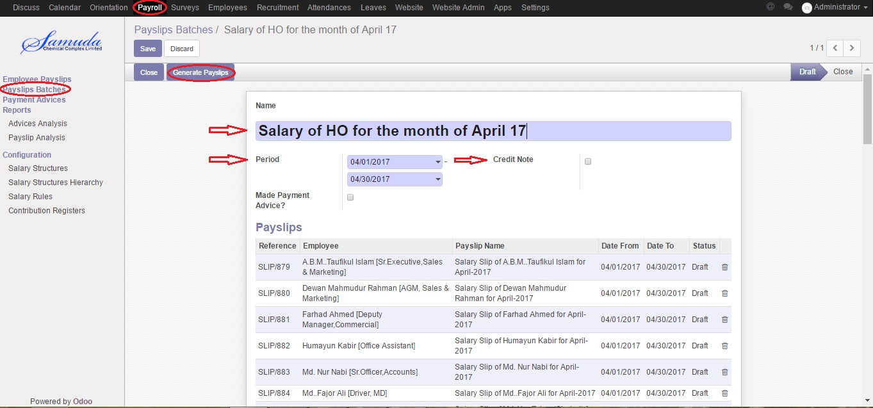

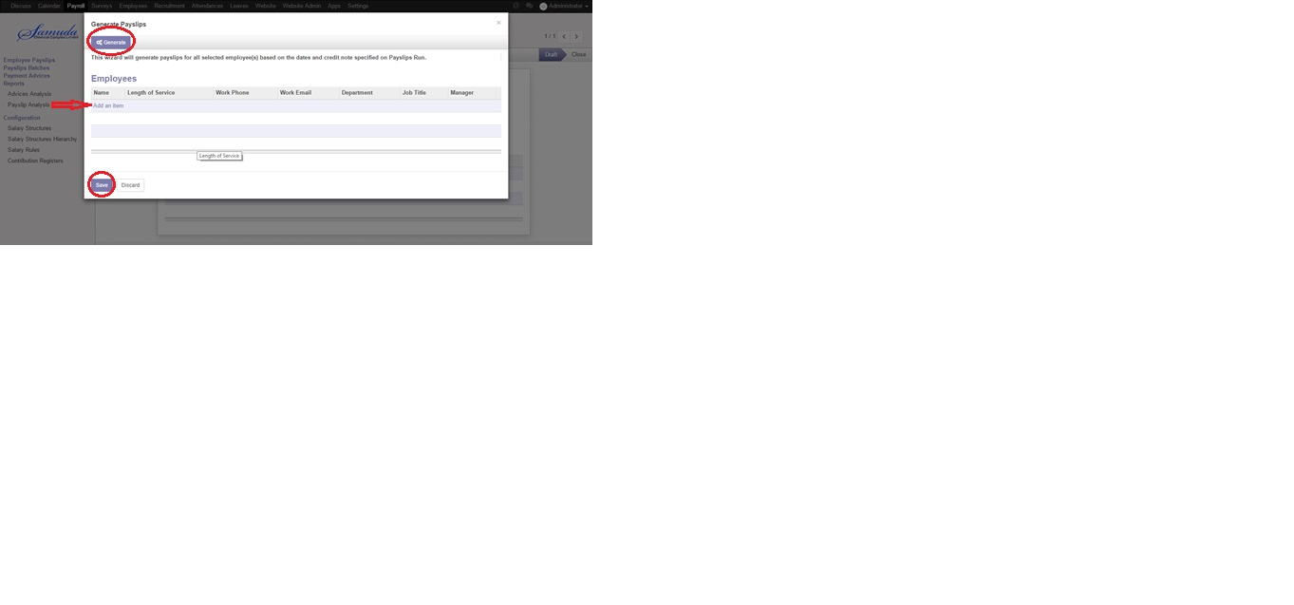

Figure: Create Payslips Batches